Model Question Paper – Cloud Data Engineer - Jain University

HCL ID: HCLTFP2170249

NAME: DHARUN P

USN: 23BTRCL014

DEPARTMENT: AIML

SECTION A: ADVANCED SQL || Maximum Marks: 20 Question 1: Database Design and Advanced Queries (8 Marks)
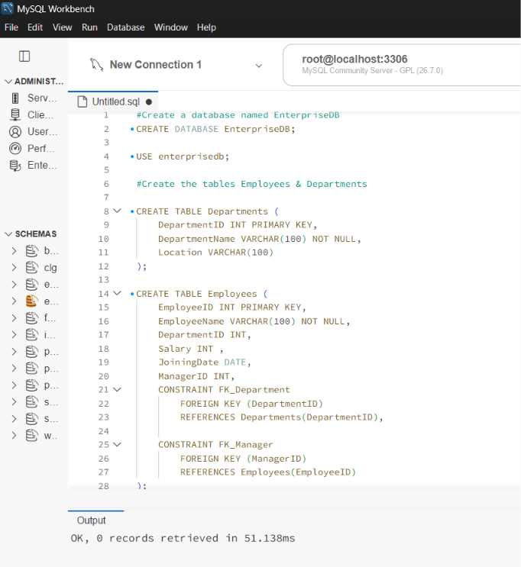
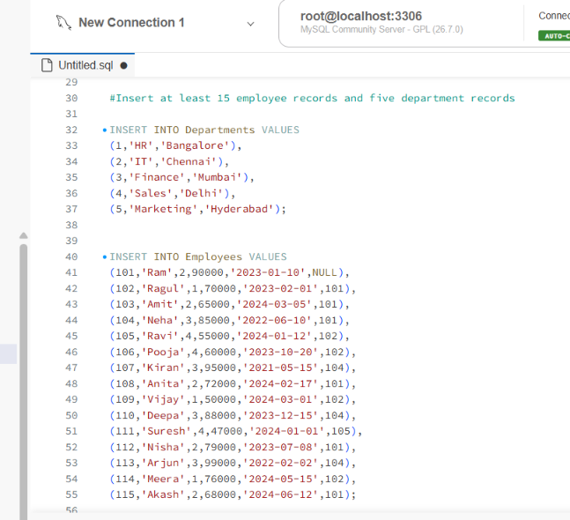
Tasks: a. Display employee names, department names, and manager names using joins. (2 marks)
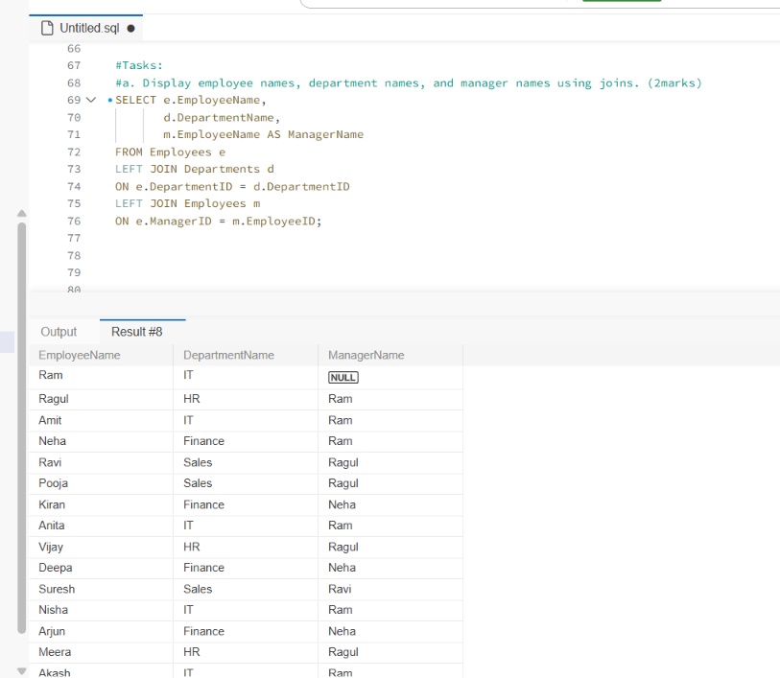
b. Find employees earning more than their department's average salary. (2 marks)
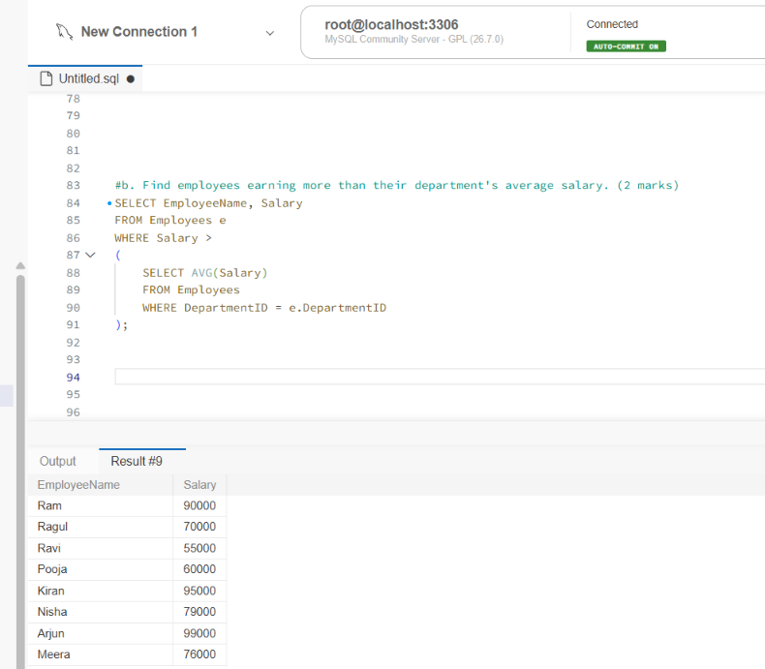
c. Find the second-highest distinct salary without using LIMIT, TOP, or FETCH FIRST. (2 marks)
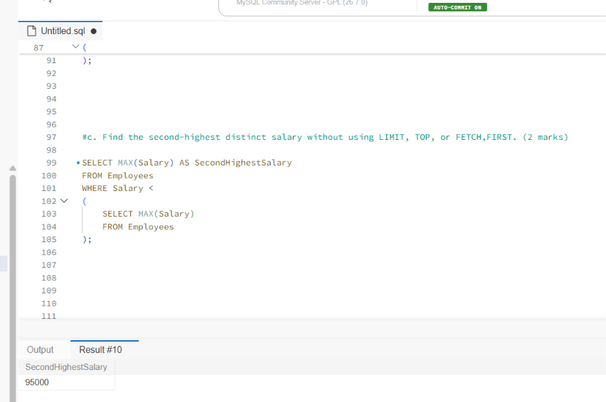
d. Rank employees by salary within each department and display the top three employees per department, retaining ties at the cutoff. (2 marks)
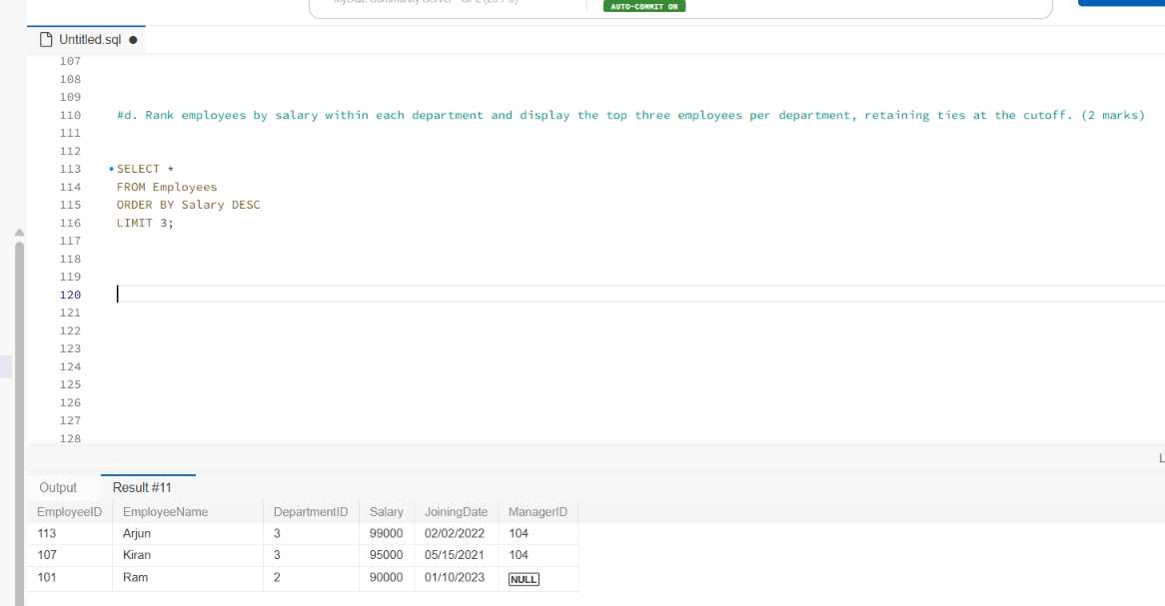
Question 2: Sales Analytics and Query Optimization (6 Marks)
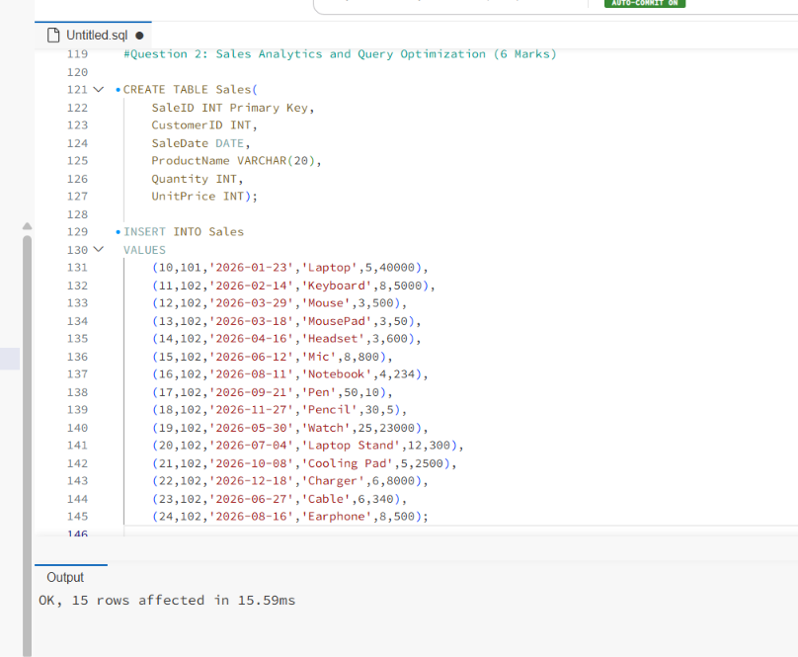
- Calculate total revenue for each product. (2 marks)
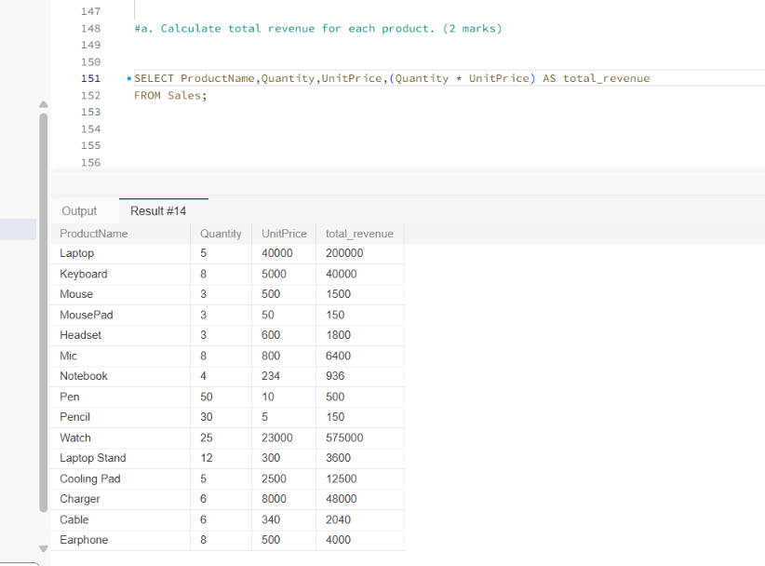
- Calculate monthly revenue and month-over-month revenue change using a window function. (2 marks)
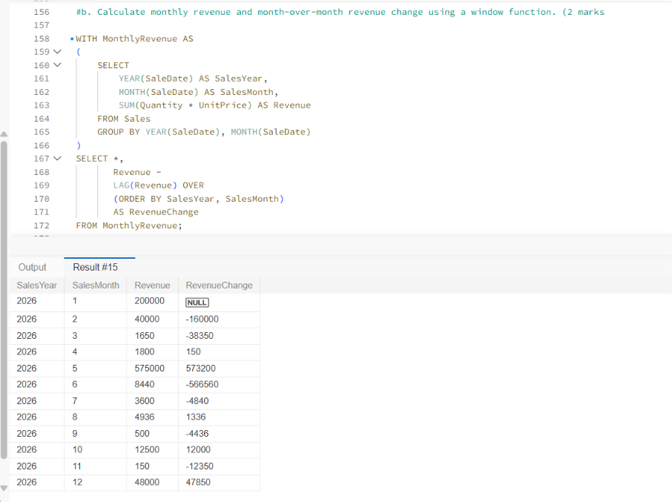
- Rewrite the following query to improve the potential for index usage and explain why your version may perform better. (2 marks)
SELECT * FROM Employees
WHERE YEAR(JoiningDate) = 2025;
Assume JoiningDate may be indexed.
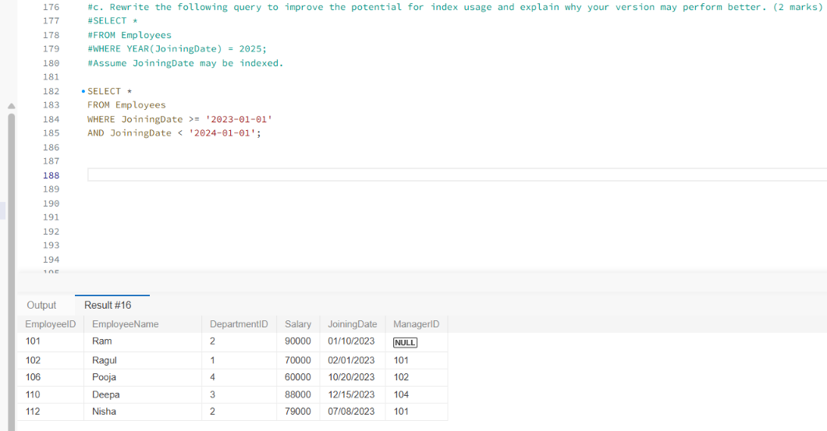

Question 3: SQL Troubleshooting (6 Marks)
A company maintains millions of employee and transaction records. Its reporting queries are running slowly. Perform the following tasks:
- Explain how an execution plan helps identify expensive operations in a query. (2 marks)
An execution plan shows how the database executes a SQL query.
It helps us:
- Understand query performance
- Identify slow operations
- Check whether indexes are being used
- Find bottlenecks in a query

- Recommend an appropriate index strategy for queries filtering employees by DepartmentID and Salary. Explain your reasoning. (2 marks)
SELECT *
FROM Employees
WHERE DepartmentID = 2;

Create an index on DepartmentID.
CREATE INDEX idx_department
ON Employees(DepartmentID);

- Write a query to identify duplicate customer email addresses and display only addresses occurring more than once. (2 marks)
SELECT EmailAddress,
COUNT(*)
FROM Customers
GROUP BY EmailAddress
HAVING COUNT(*) > 1;

SECTION B: LINUX || Maximum Marks: 15

Question 4: Log Analysis (5 Marks) Assume /var/log/application.log contains millions of log entries in the following format:
2026-10-28 10:15:23 ERROR payment-service Transaction failed
Write Linux commands to:

a.Find all lines containing ERROR. (1 mark)

ANSWER: grep "ERROR" application.log

b. Display the 20 most recent error entries in the file. (1 mark)

ANSWER: grep "ERROR" application.log | tail -20

c. Count the total number of error entries. (1 mark)

ANSWER: grep -c "ERROR" application.log

d. Extract error entries for a specified date into a separate file. (1 mark)

ANSWER: grep "2025-01-10" application.log > output.log

e. Explain how you would calculate the number of errors occurring in each hour. (1 mark)

ANSWER: grep "ERROR" application.log | cut -d':' -f1 | sort | uniq -c

Question 5: Permissions and System Troubleshooting (5 Marks) A Linux server hosts an application that processes confidential financial reports.
Perform the following tasks:
a. Create a group named finance and a report file, assuming you have the required privileges. (1 mark)
sudo groupadd finance
touch report.txt
b. Set permissions so the owner can read and write, the finance group can read, and other users have no access. (1 mark)
chgrp finance report.txt
chmod 640 report.txt
c.Identify the processes consuming the most CPU. (1 mark)
ps aux --sort=-%cpu | head -6
d.Display memory usage and filesystem disk utilization. (1 mark)
memory: free -h
disk: df -h
e. Find files larger than 100 MB under a specified application directory. (1 mark)
find /app -type f -size +100M
SECTION C: PYSPARK DATA ENGINEERING || Maximum Marks: 20
Question 7: PySpark DataFrame Operations (6 Marks)
Create a PySpark DataFrame containing the following columns:
• EmployeeID
• EmployeeName
• Department
• Salary
• JoiningDate Insert at least 15 sample records.
Write and execute a PySpark program to:
a. Display the schema and first five records. (1 mark)
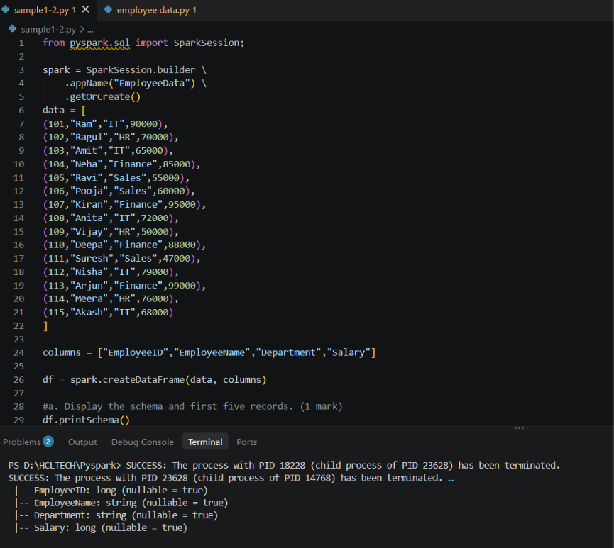

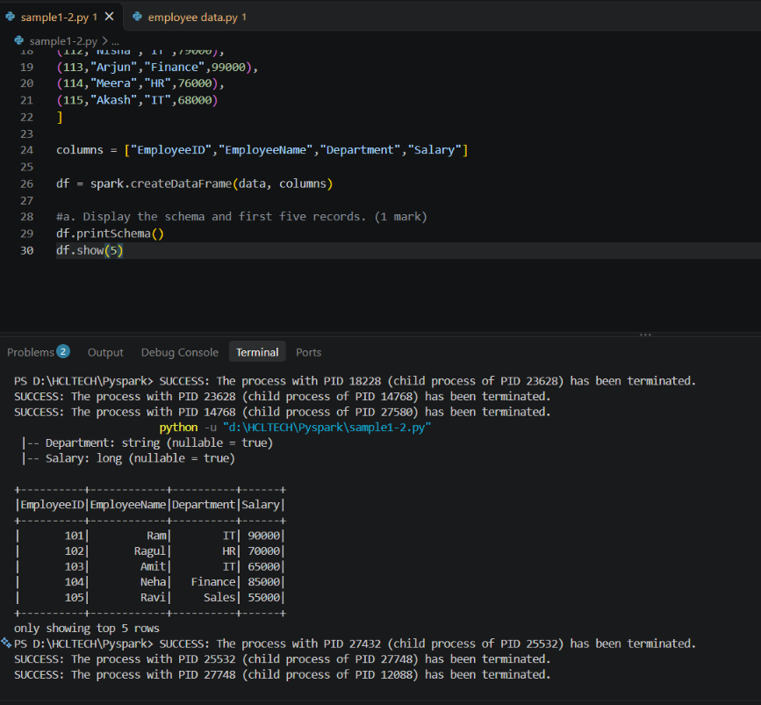
b. Filter employees whose monthly salary is greater than ₹60,000. (1 mark)
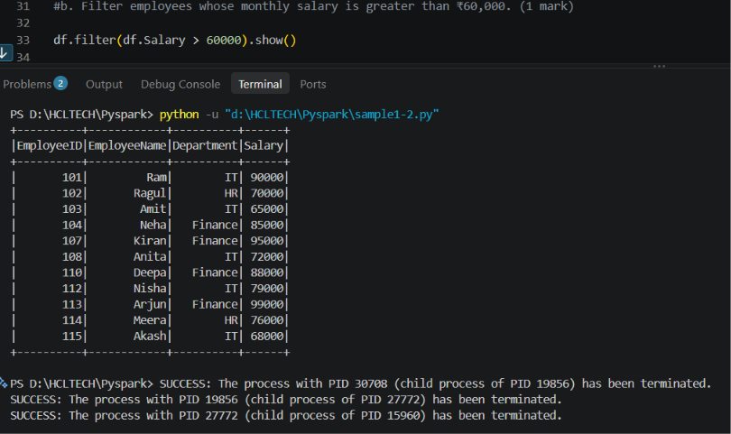
c. Add an AnnualSalary column calculated from the monthly salary. (1 mark)
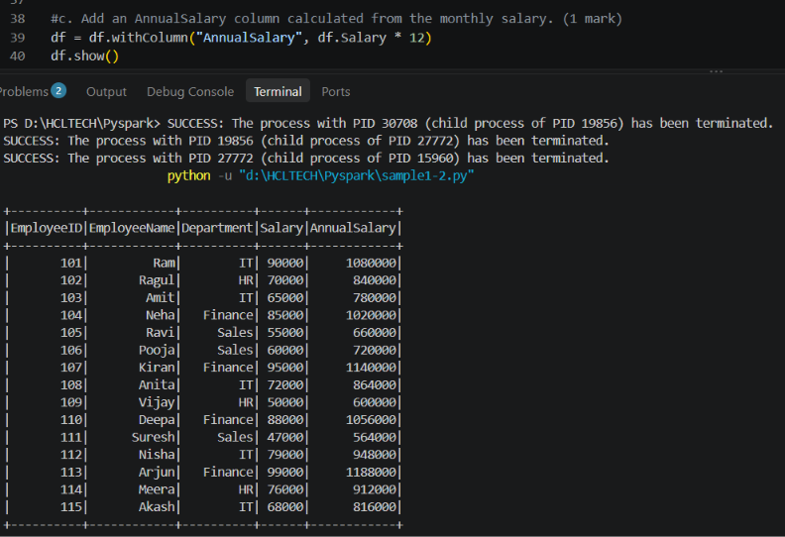
d. Group employees by department and calculate the average salary and employee count. (2 marks)
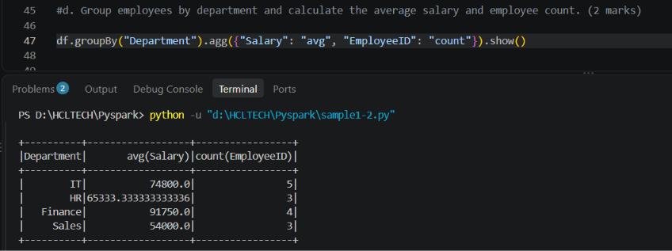
e. Display the five highest-paid employees. (1 mark)
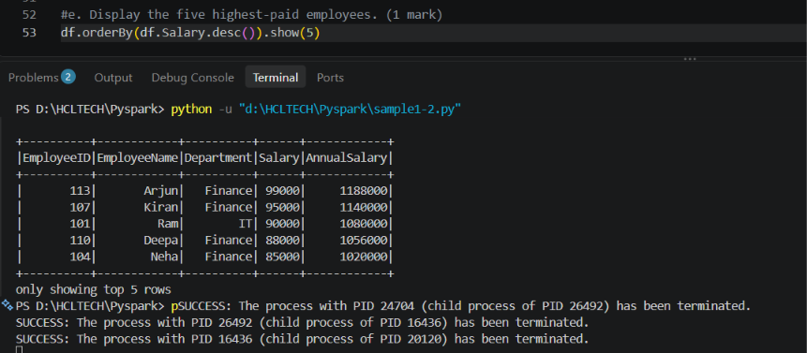

Question 8: Data Cleaning and Aggregation (7 Marks)
A company receives a CSV file named transactions.csv containing:
• TransactionID
• CustomerID
• TransactionDate
• Product
• Quantity
• UnitPrice The file contains duplicate records, missing values, and incorrectly formatted dates. Write a PySpark program to:
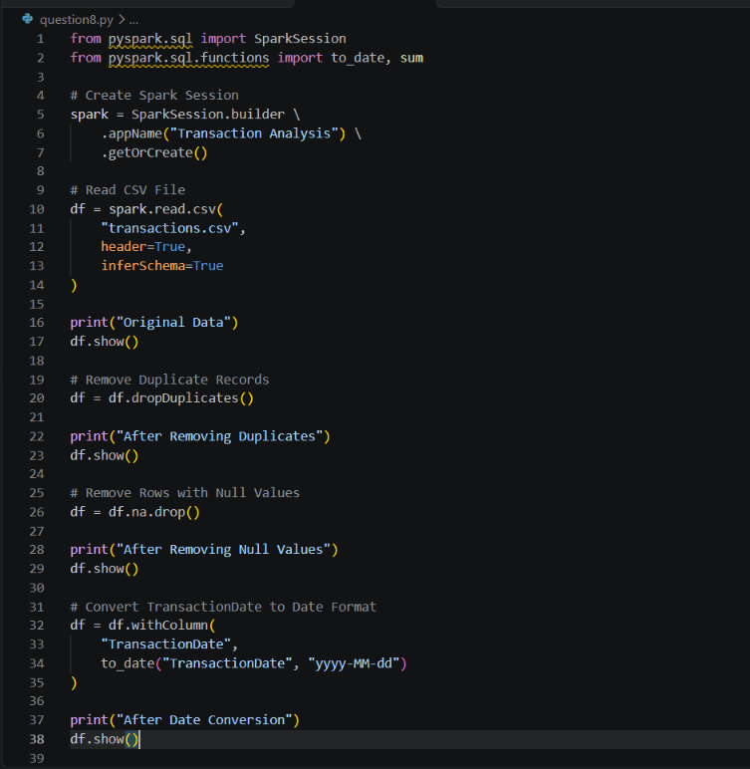
a. Read the CSV file using an appropriate schema and header configuration. (1 mark)
b. Identify and remove duplicate transactions using a suitable business key. (1 mark)
c. Handle missing values in required fields and explain your chosen approach. (2 marks)
d. Convert TransactionDate into a date type and handle invalid dates. (1 mark)
e. Calculate revenue using Quantity × UnitPrice. (1 mark)
f. Calculate total revenue by product and display the results in descending order. (1 mark)
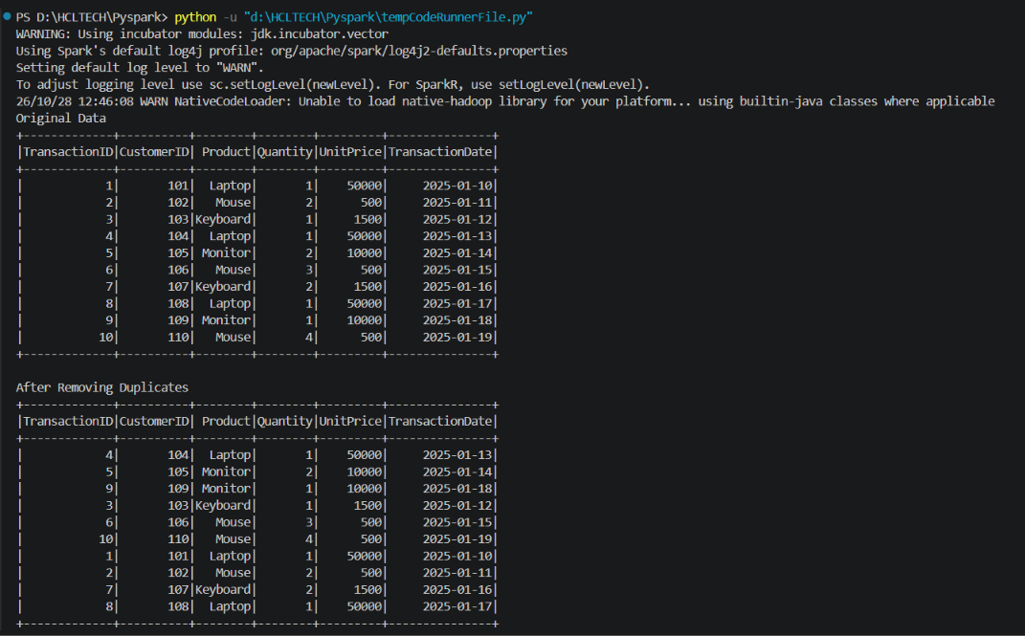
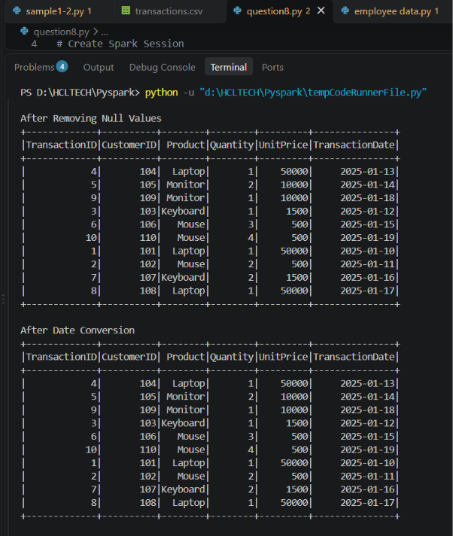
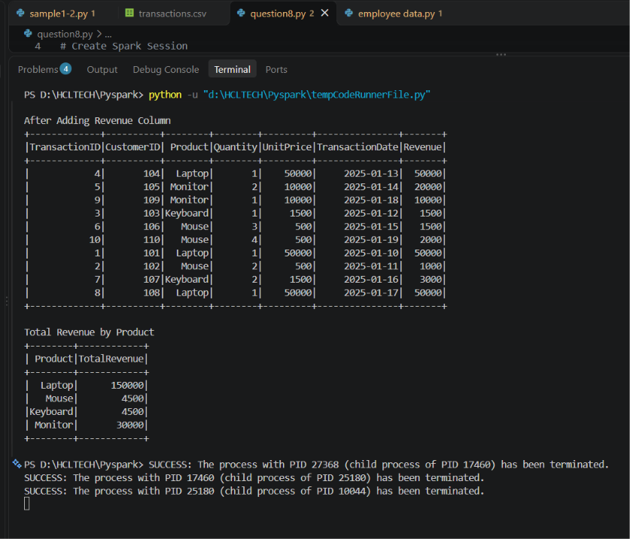
Question 9: PySpark Joins and Performance (7 Marks)
A company maintains two datasets.
Customers
• CustomerID
• CustomerName
• City
Orders
• OrderID
• CustomerID
• OrderAmount
• OrderDate
Write a PySpark program to:
a. Load both datasets into DataFrames. (1 mark)
b. Join the datasets to display orders with customer details. (2 marks)
c. Identify customers who have never placed an order. (1 mark)
d. Calculate the total order value by city. (1 mark)
e. Explain when a broadcast join is useful and what conditions make it appropriate. (1 mark)
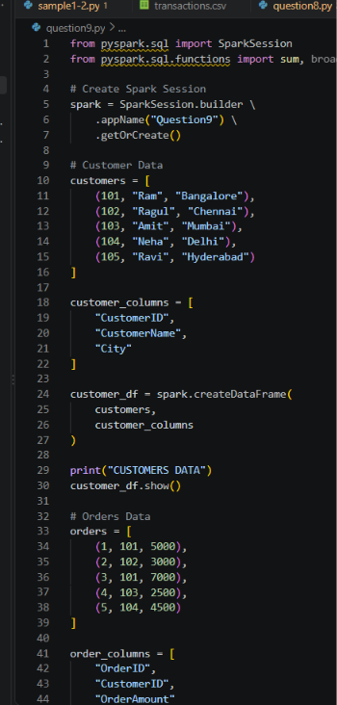
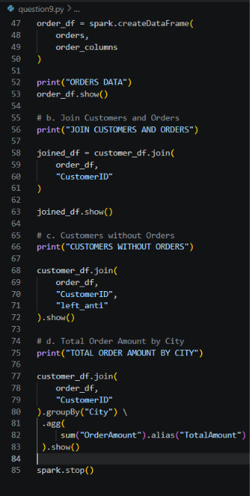
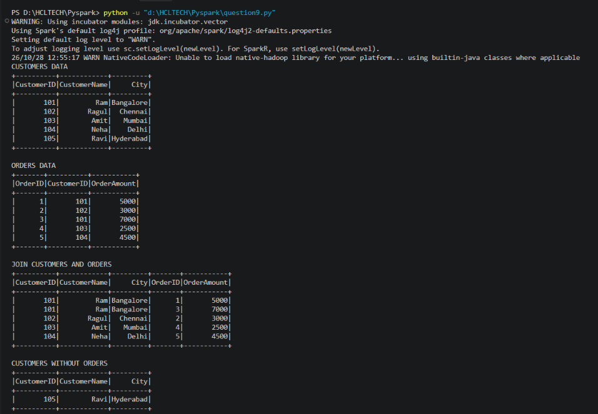

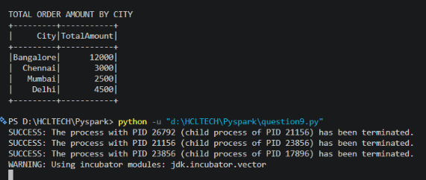
SECTION D: AWS CLOUD SERVICES || Maximum Marks: 15
Question 10: S3 and IAM Security (5 Marks)
A company stores confidential employee reports in Amazon S3. Only authorized HR employees should be able to read these reports.
Perform or document the following:
a. Create an S3 bucket with Block Public Access enabled and upload a sample file. (1 mark)
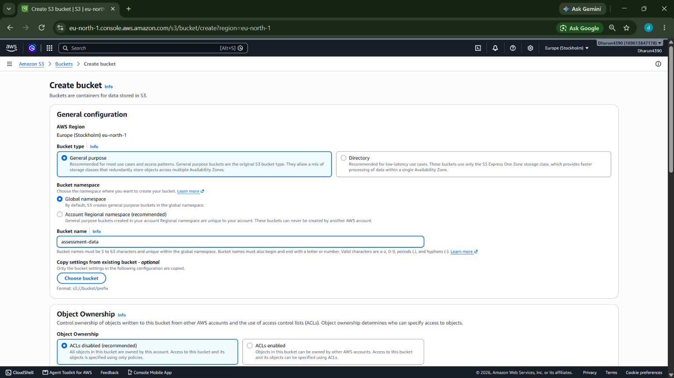
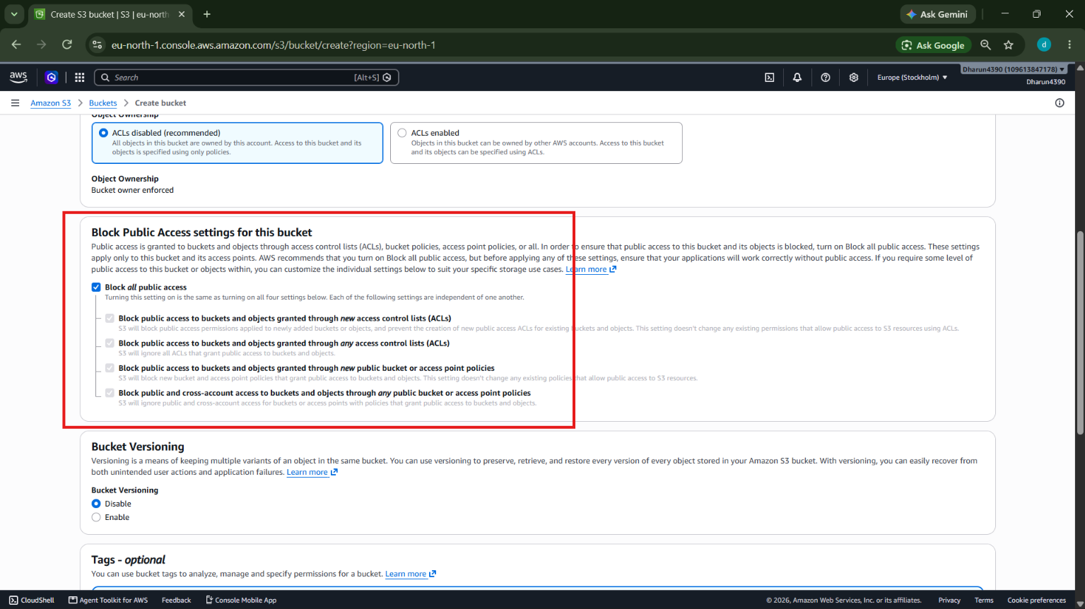
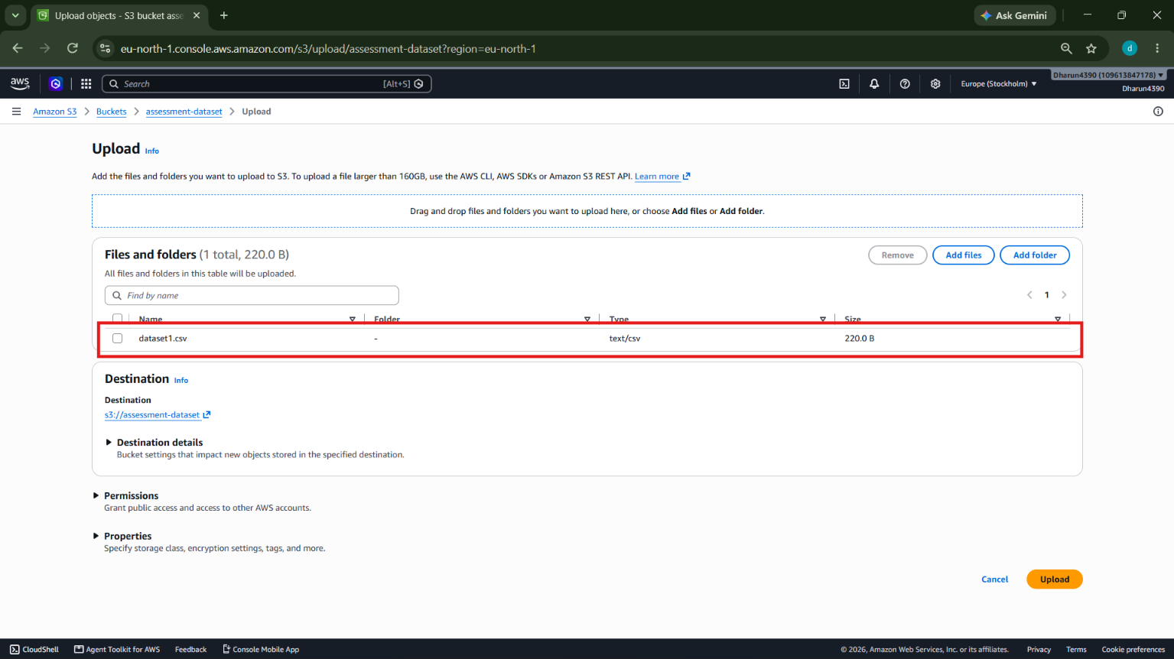
b. Design an IAM policy that grants read access to objects in the designated bucket without granting access to unrelated buckets. (2 marks)
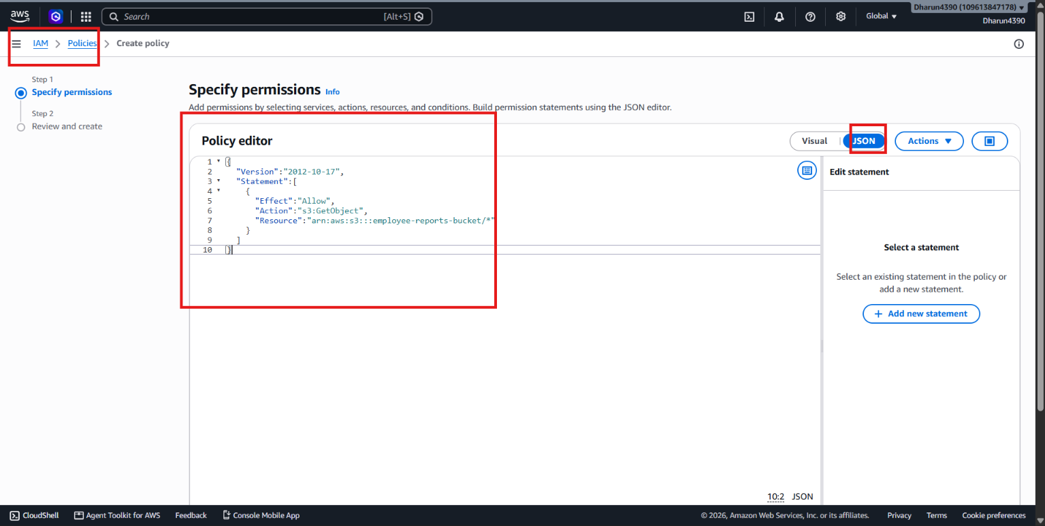
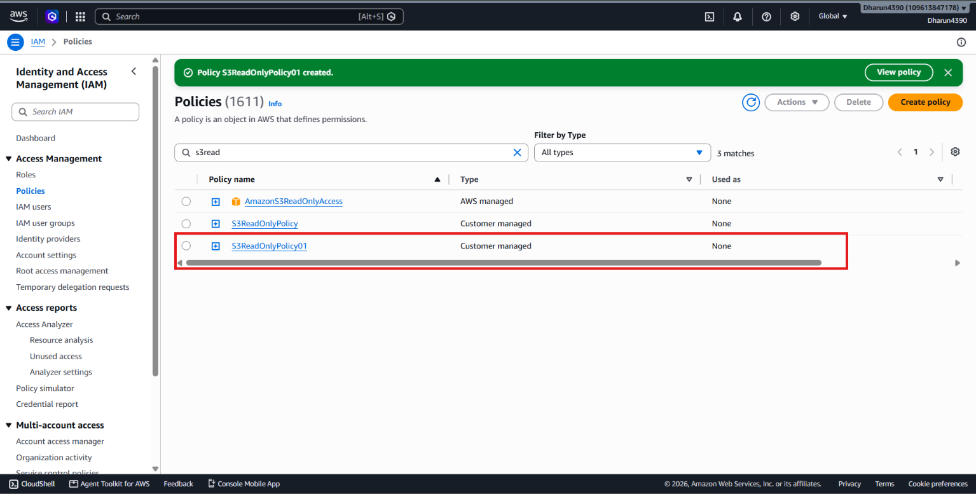
c. Explain how you would verify that an unauthorized user cannot read the file. (1 mark)
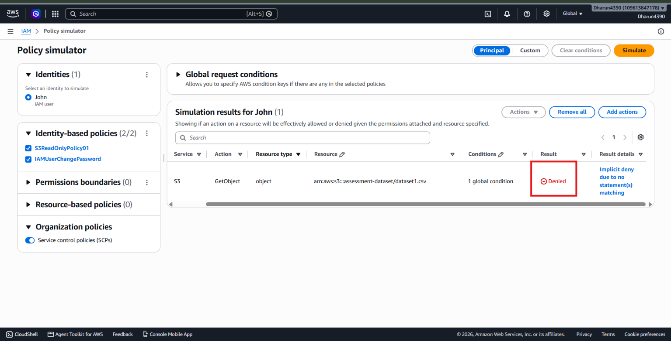
d. Explain how encryption at rest protects the stored data. (1 mark)
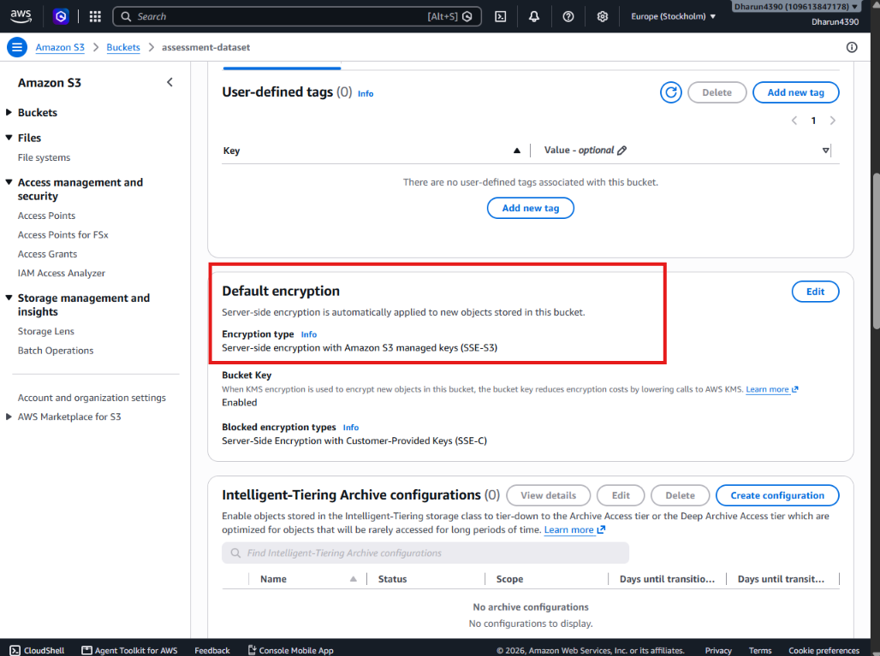
Question 11: EC2 Troubleshooting and CloudWatch (5 Marks)
A web application hosted on EC2 becomes slow, and users report connectivity problems.
Perform or document the following:
a. Check the EC2 instance state and status checks. (1 mark)
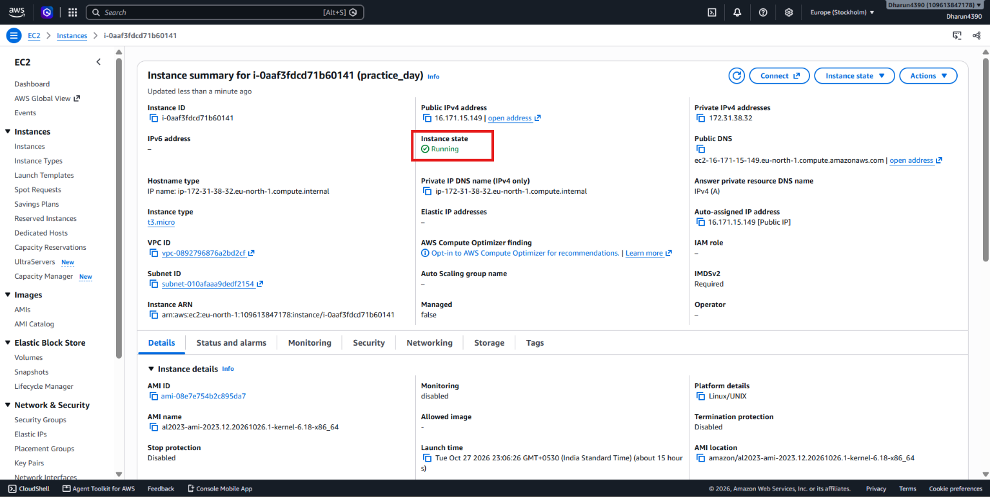
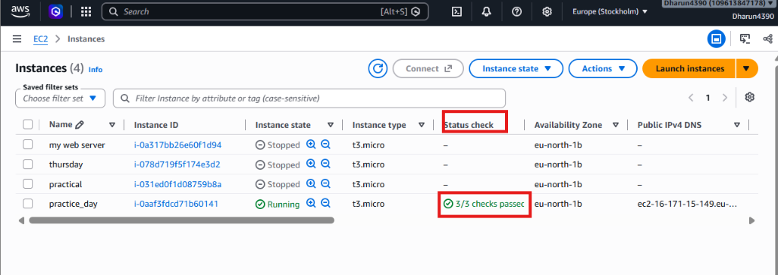
b. Explain how security groups and route tables can affect application connectivity. (1 mark)
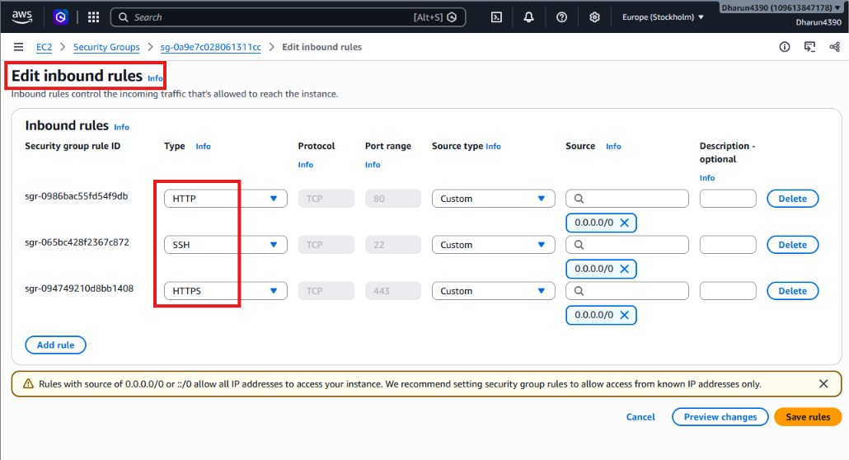
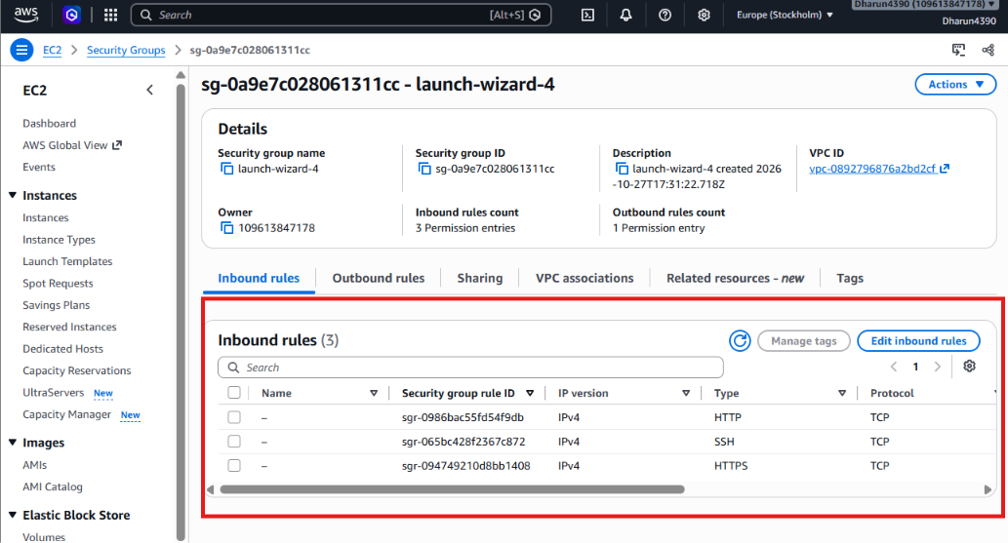
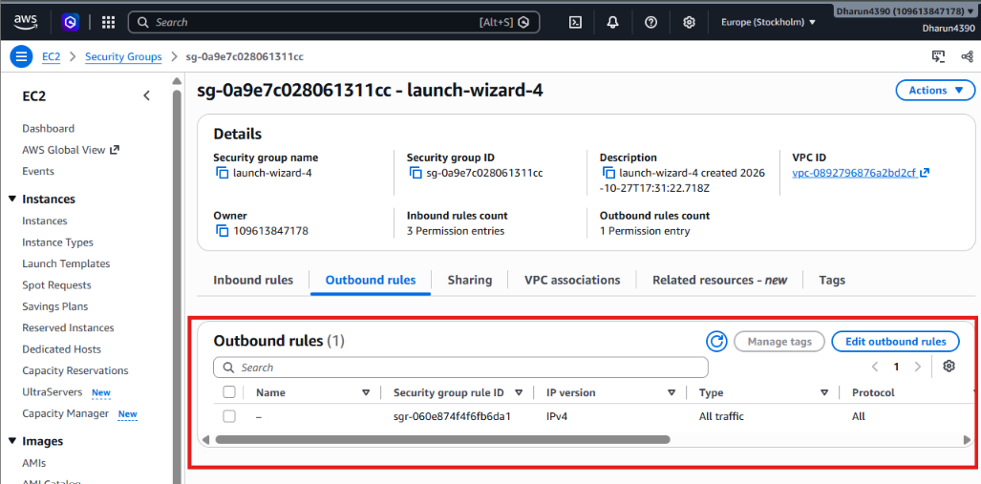

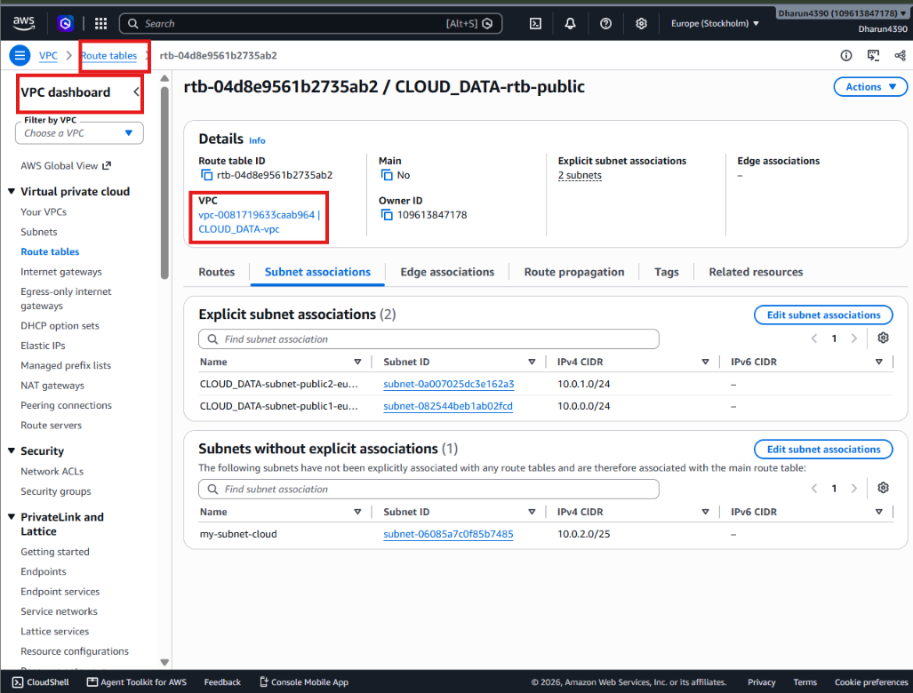
c. Explain how to configure a CloudWatch alarm when CPU utilization exceeds 85% for a defined evaluation period. (2 marks)
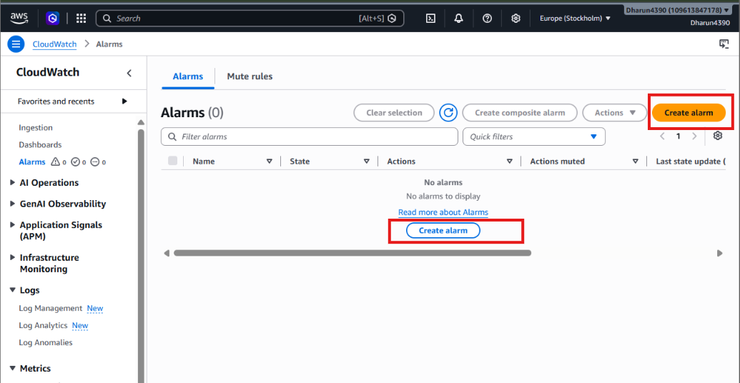
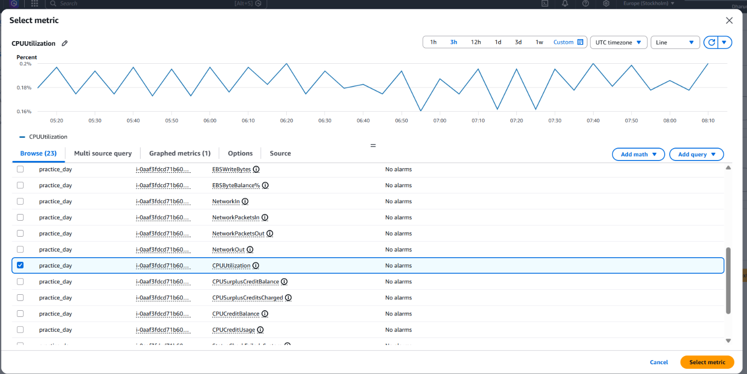
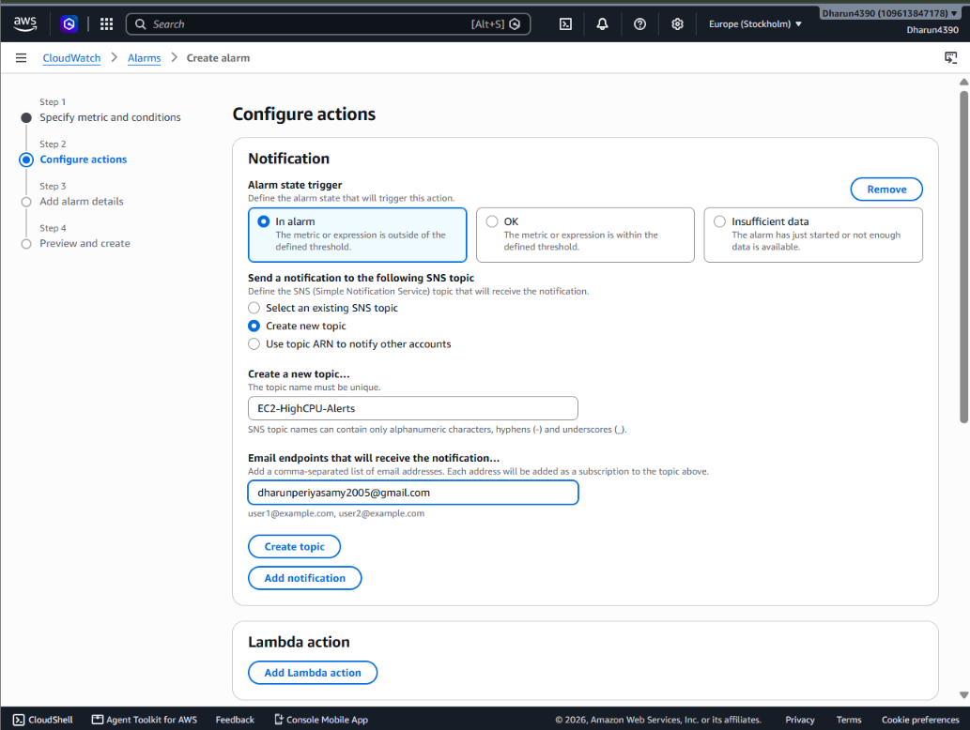
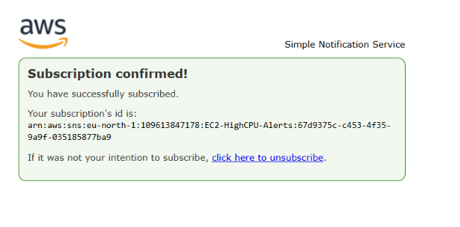
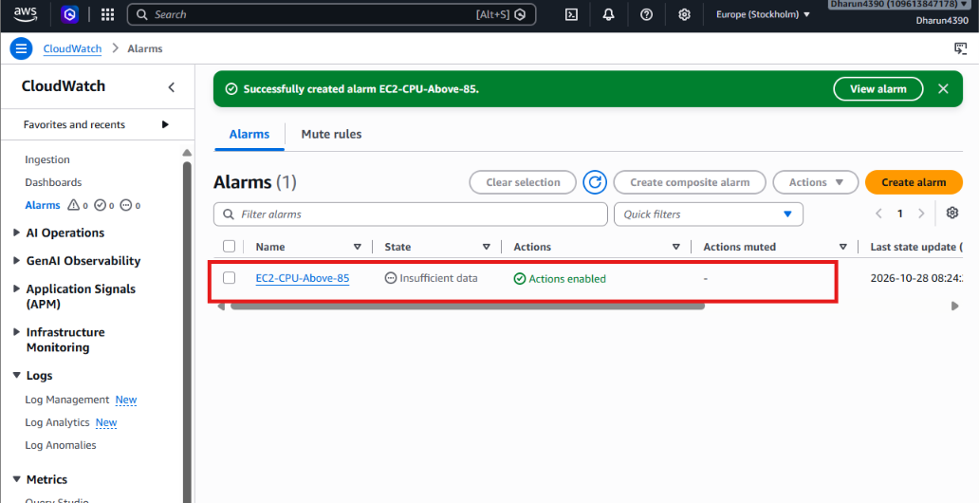
d. Identify one method for investigating the root cause of high CPU utilization. (1 mark)
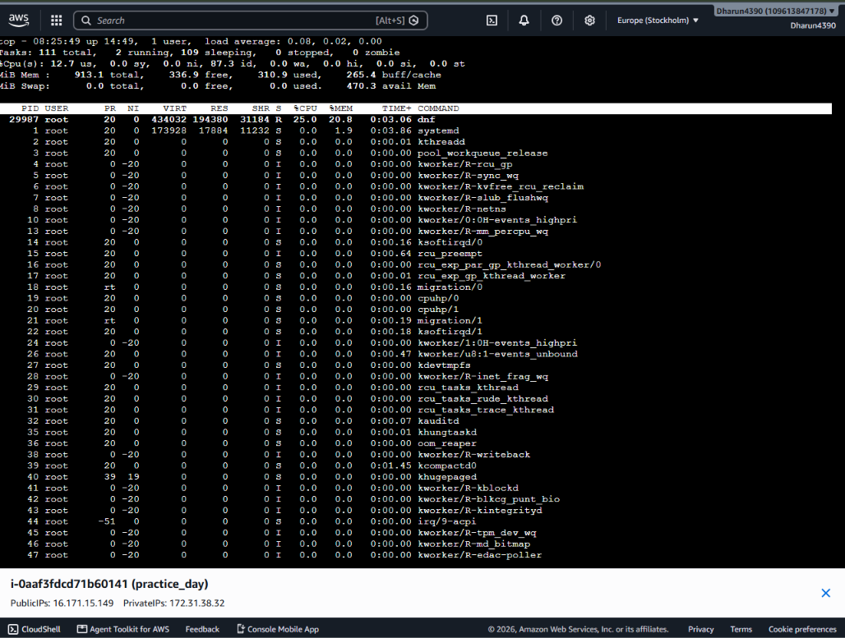
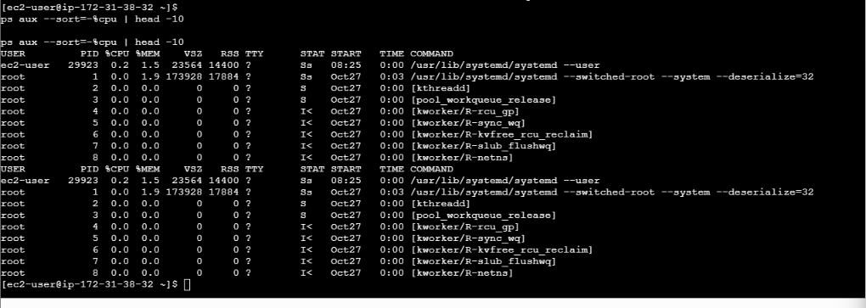
Question 12: Event-Driven Processing (5 Marks)
A company uploads CSV files to an S3 bucket.
Each uploaded file must be validated and processed automatically, with the results stored in another location.
Design a solution using AWS services.
a. Identify a suitable service for executing the processing code. (1 mark)
Create an AWS Lambda function that will execute Python code whenever a CSV file is uploaded to Amazon S3.
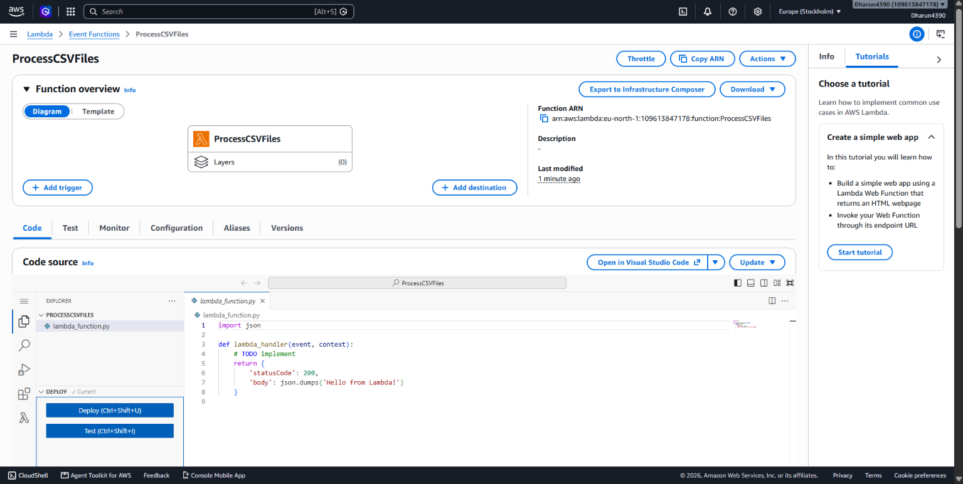
b. Explain how an S3 upload can trigger processing. (1 mark)
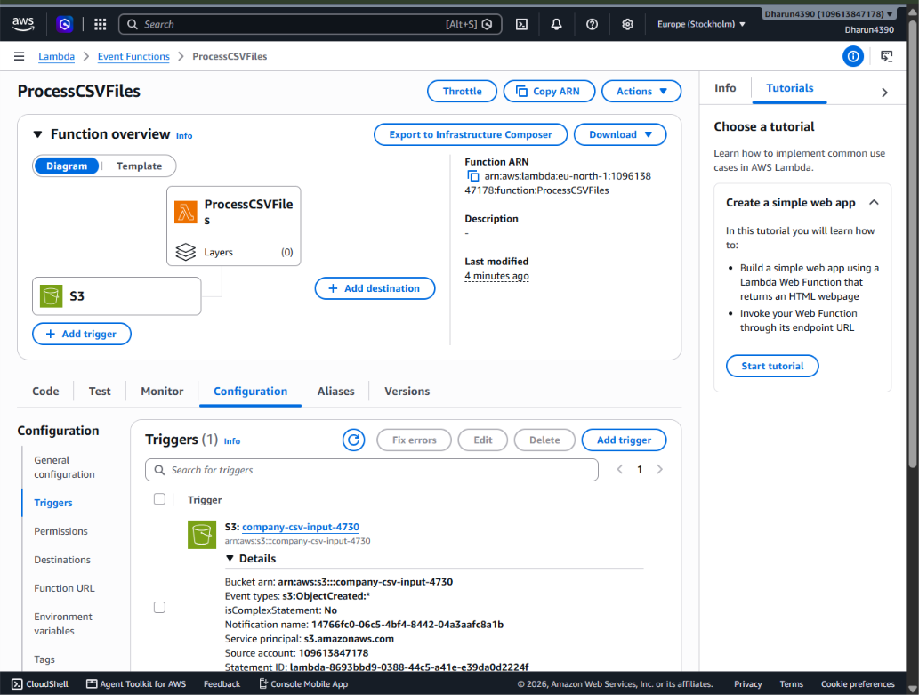
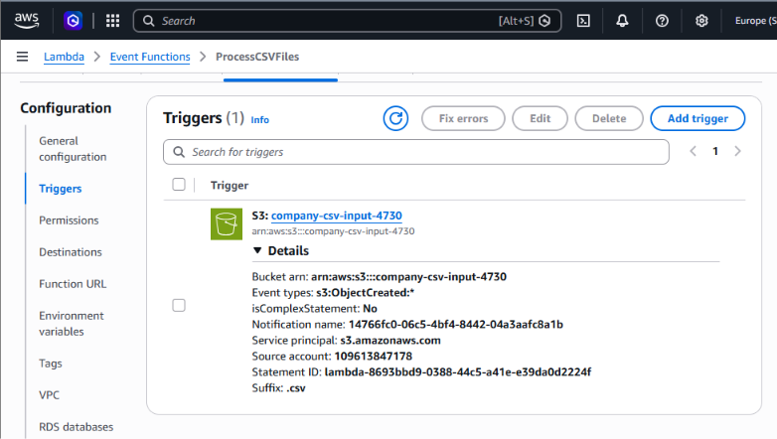
c. Explain the IAM permissions needed to read the input file and write the results. (1 mark)
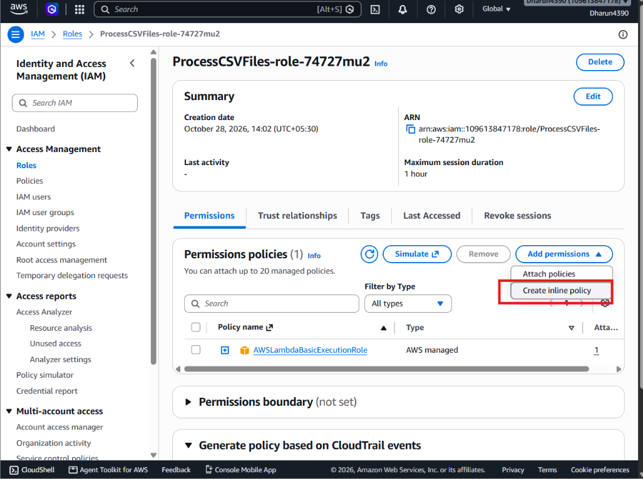
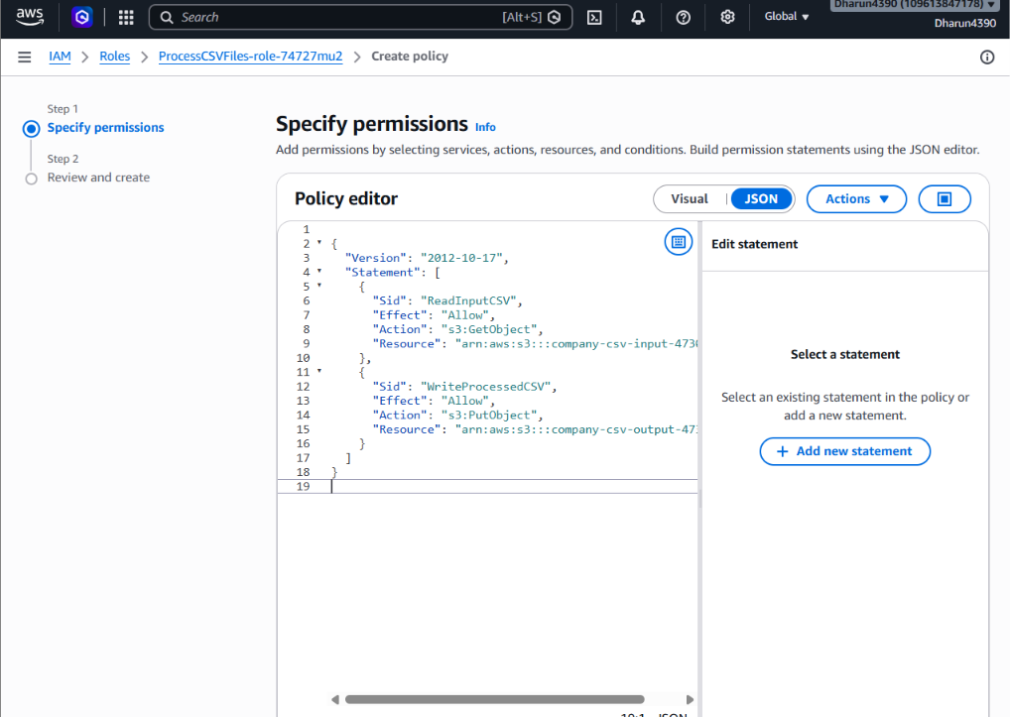
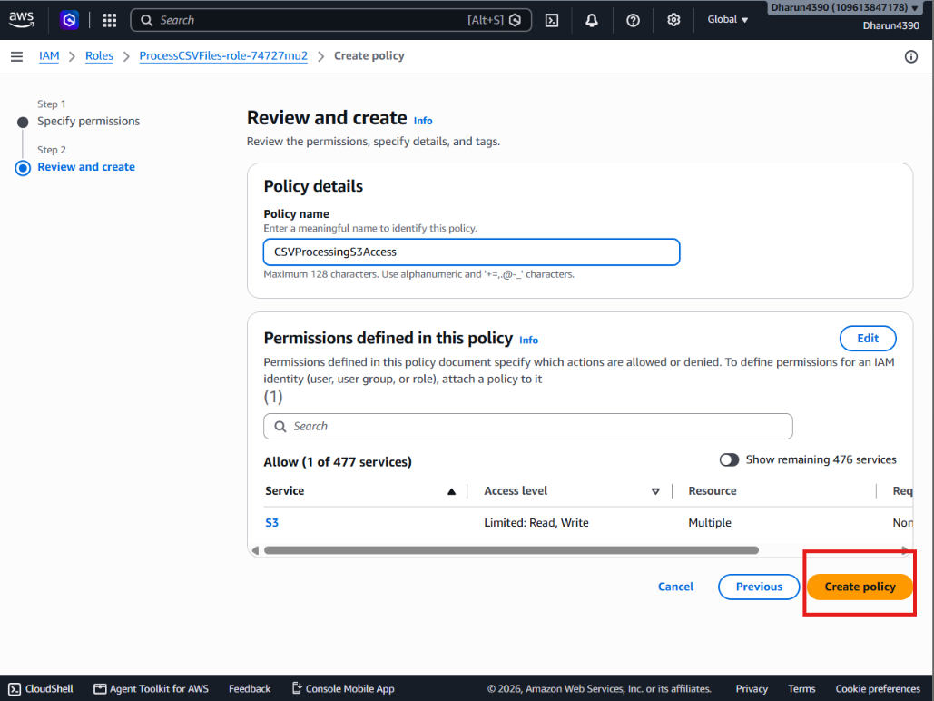
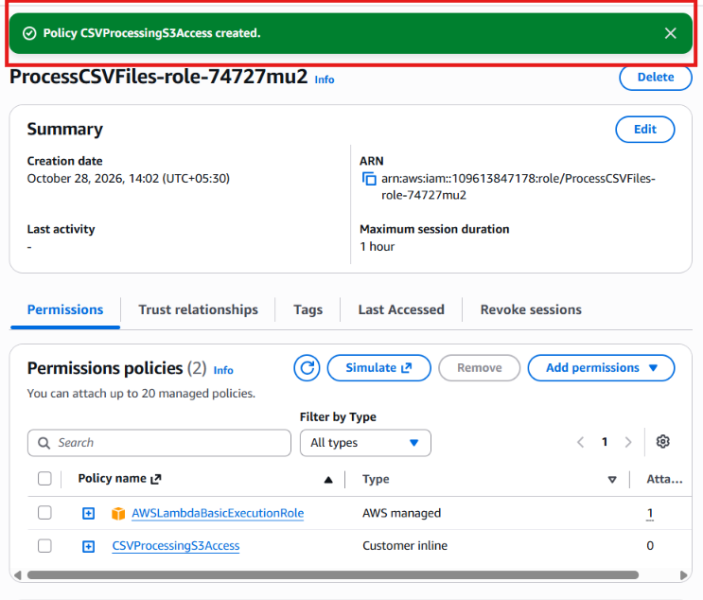

d. Explain how errors and processing logs can be captured. (1 mark)
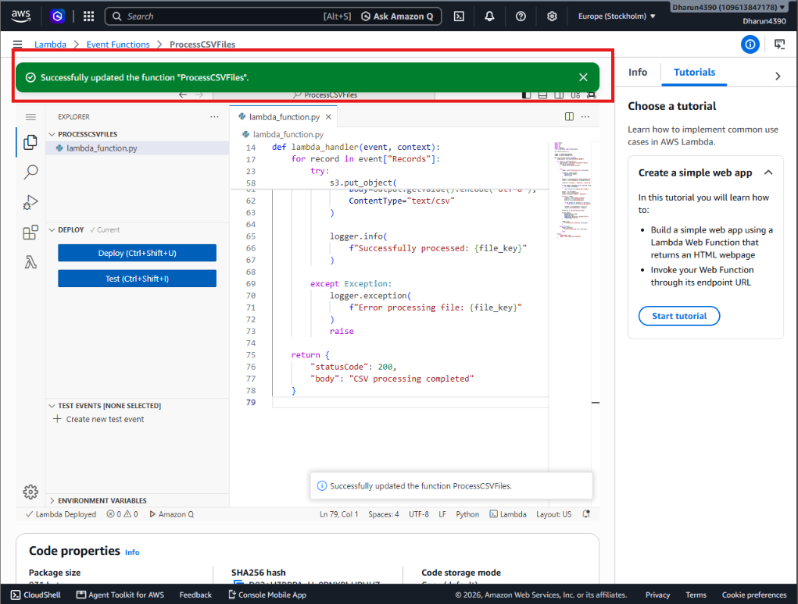
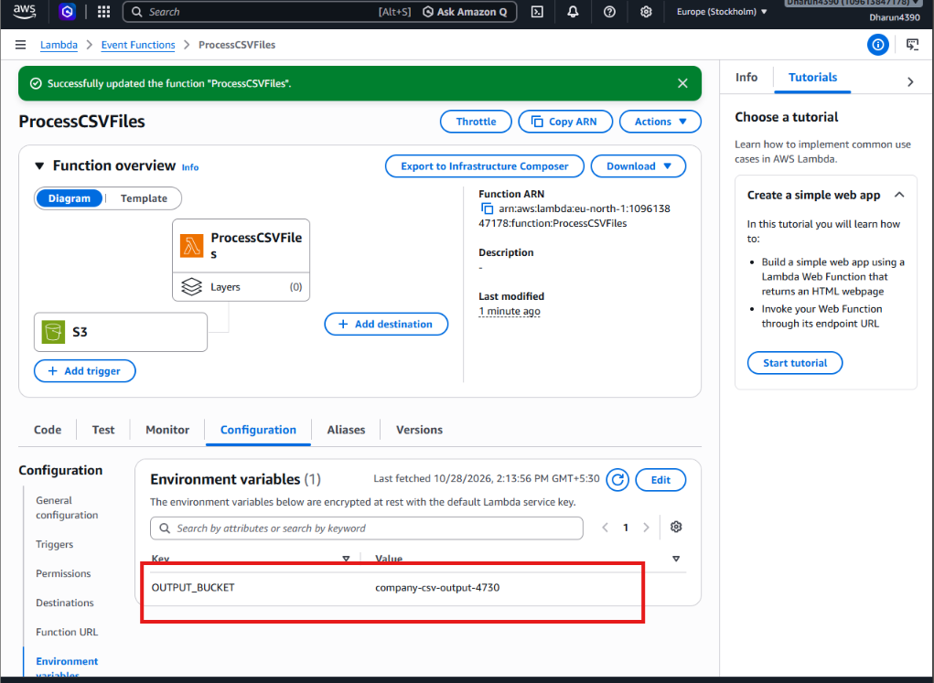
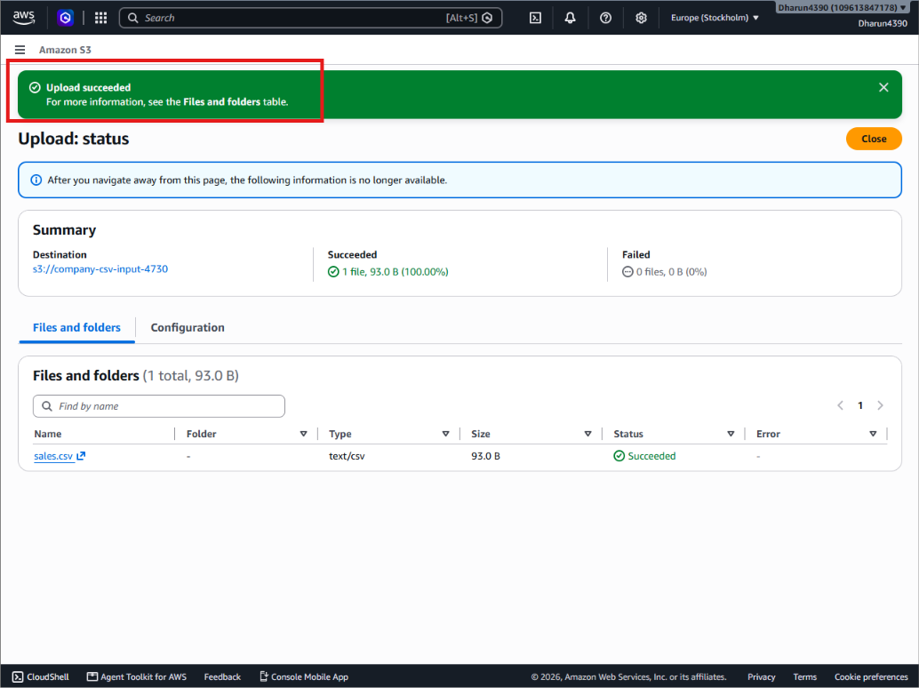
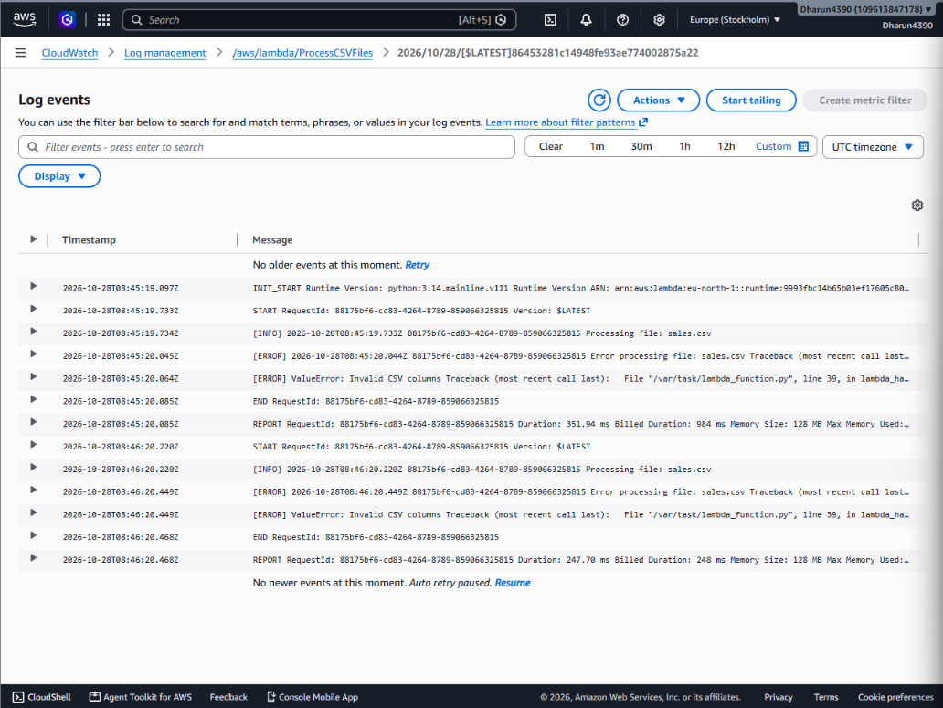
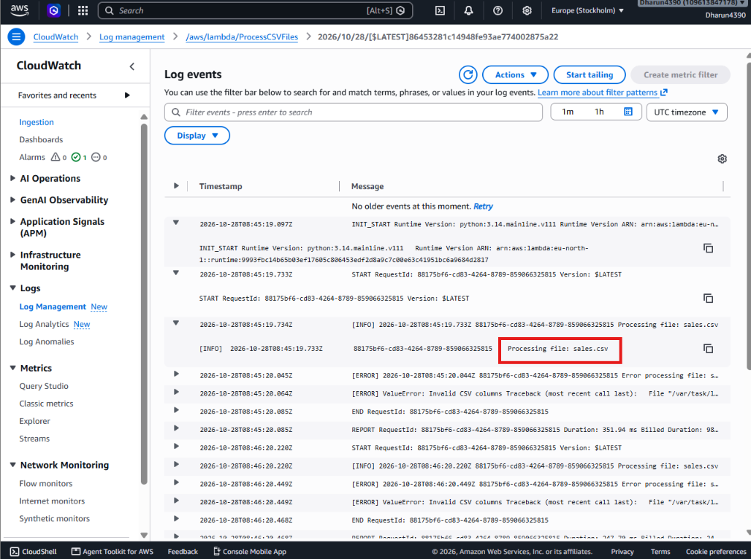
e. Explain how to prevent duplicate processing or recursive triggering. (1 mark)
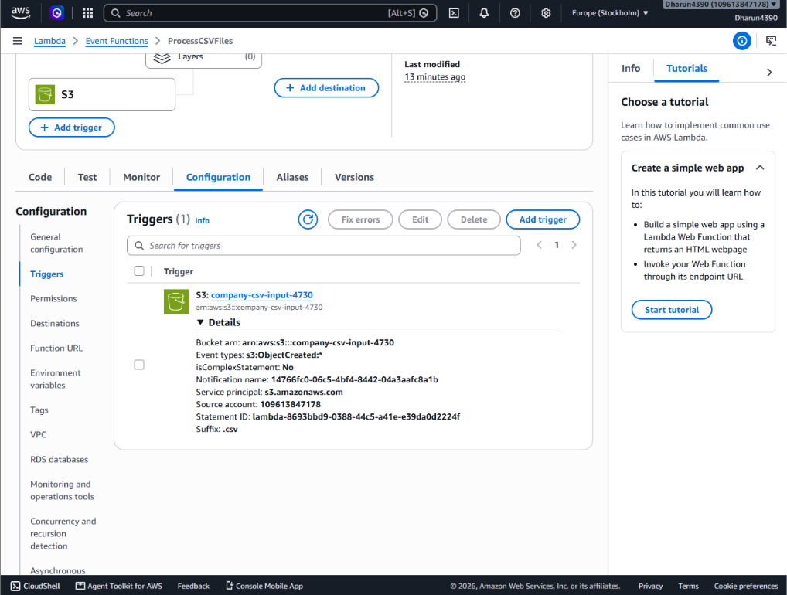
SECTION E: AWS STEP FUNCTIONS || Maximum Marks: 15
Question 13: State Machine Design (7 Marks)
A company needs to process sales files through the following stages:
1. Validate the input file.
2. Transform the data.
3. Calculate total sales by product.
4. Store the results in Amazon S3.
5. Send a completion notification.
Design an AWS Step Functions state machine to coordinate the workflow.
a. Identify suitable states for validation, processing, storage, and notification. (2 marks)

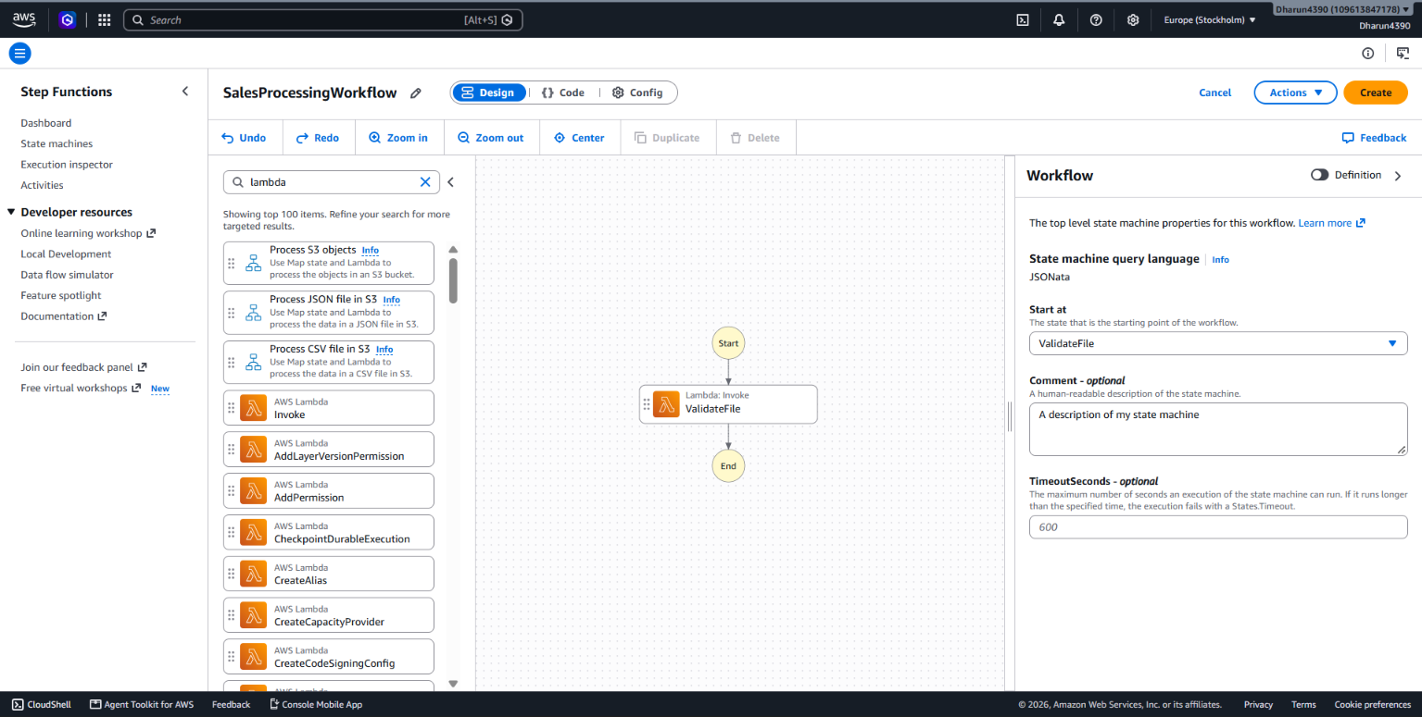
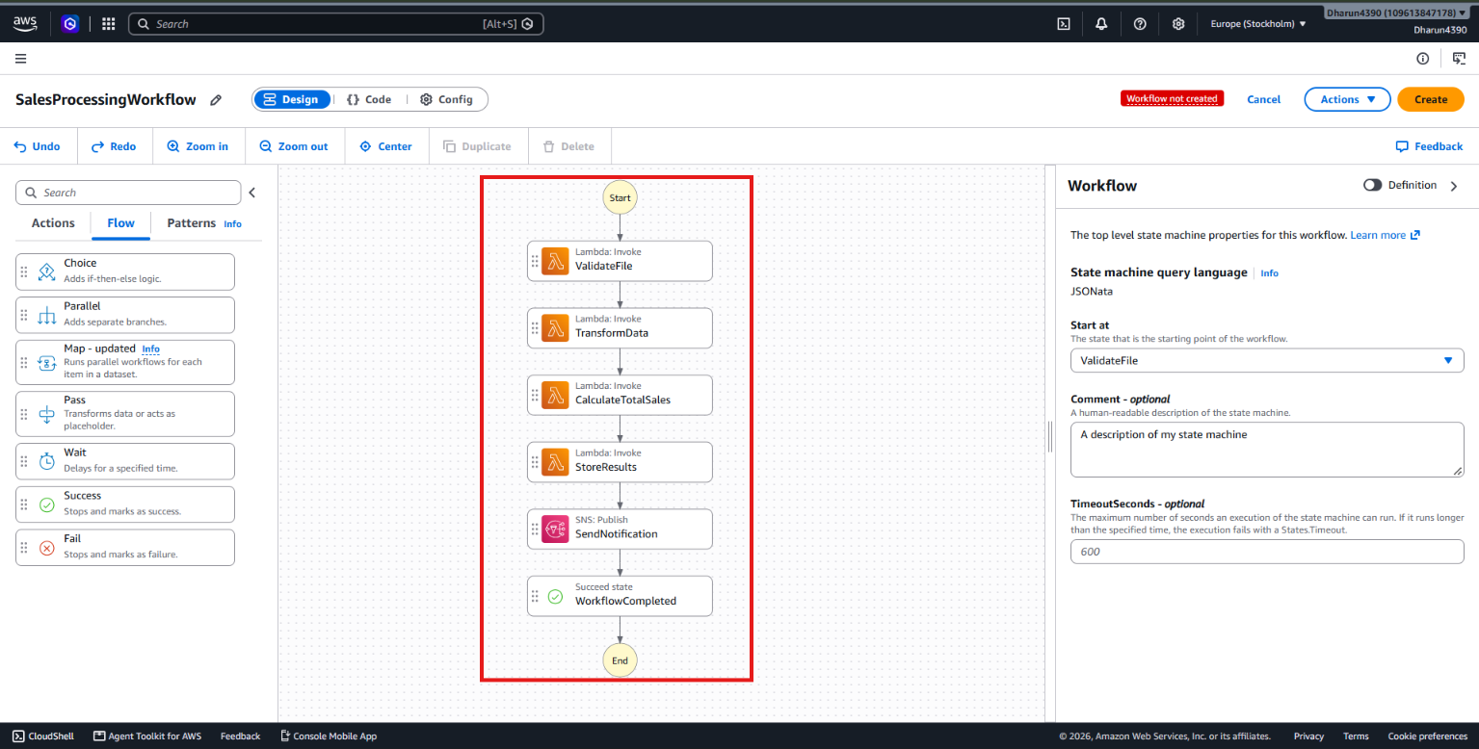
b. Explain how a Choice state can route invalid files to a failure path and valid files to processing. (1 mark)
A Choice state evaluates the validation result returned by the validation task.
If isValid is true, the workflow proceeds to the data transformation state.
Otherwise, the workflow transitions to a Fail state, stopping further processing of invalid files.
c. Explain how Retry and Catch can handle transient failures and permanent errors. (2 marks)
The purpose is to make your workflow handle errors automatically instead of stopping immediately.
d. Explain how the state machine can invoke Lambda functions or other supported AWS services. (1 mark)
Our goal is to connect the five processing states to actual AWS services.
AWS Step Functions uses Task states to invoke AWS Lambda functions and other AWS services.
- ValidateFile: Checks whether the CSV file is valid.
- TransformData: Cleans and transforms the data.
- CalculateTotalSales: Calculates total sales by product.
- StoreResults: Saves processed results to Amazon S3.
- SendNotification: Uses Amazon SNS to send a completion notification.

e. Explain how execution history helps troubleshoot a failed workflow. (1 mark) Expected Output: Draw the workflow or submit an Amazon States Language (ASL) definition
AWS Step Functions maintains an execution history that records every step performed by a state machine.
- Execution status: Shows whether the workflow succeeded, failed or is running.
- State details: Shows which task executed successfully or failed.
- Input and output: Displays the data received and returned by each state.
- Error messages: Helps identify why a task failed.
- Retry details: Shows repeated attempts after temporary failures.
Question 14: Step Functions Implementation (8 Marks)
A data engineering team has developed three processing functions:
• ValidateFile
• TransformData
• LoadResults The functions must execute in sequence.
Requirements:
• If validation fails, the workflow must stop.
• If transformation fails temporarily, the workflow must retry.
• If loading fails permanently, the workflow must record the failure.
Tasks:
a. Write an ASL JSON definition containing the three sequential tasks. Use placeholders for resource ARNs where necessary. (3 marks)
{
"Comment": "Sales File Processing Workflow",
"StartAt": "ValidateFile",
"States": {
"ValidateFile": {
"Type": "Task",
"Resource": "arn:aws:states:::lambda:invoke",
"Parameters": {
"FunctionName": "VALIDATE_LAMBDA_ARN",
"Payload.$": "$"
},
"OutputPath": "$.Payload",
"Next": "TransformData"
},
"TransformData": {
"Type": "Task",
"Resource": "arn:aws:states:::lambda:invoke",
"Parameters": {
"FunctionName": "TRANSFORM_LAMBDA_ARN",
"Payload.$": "$"
},
"OutputPath": "$.Payload",
"Next": "LoadResults"
},
"LoadResults": {
"Type": "Task",
"Resource": "arn:aws:states:::lambda:invoke",
"Parameters": {
"FunctionName": "LOAD_LAMBDA_ARN",
"Payload.$": "$"
},
"OutputPath": "$.Payload",
"End": true
}
}
}
b. Configure a retry policy for the transformation task with an appropriate error category, retry interval, and maximum attempts. (2 marks)
Step 1: Fix the errors
- Open AWS Console → Step Functions.
- Open your workflow in Workflow Studio.
- Select each Lambda state and configure its Function name.
- Select SendNotification and configure the SNS topic ARN.
- Check that the red error symbols disappear.
Step 2: Create the state machine
- Click Create.
- Review the IAM execution role.
- Confirm creation.
Step 3: Execute the workflow
- Open Step Functions → State machines.
- Select SalesProcessingWorkflow.
- Click Start execution.
- Enter the test input
- Click Start execution again.

c. Configure a Catch transition for the loading task that routes to an error-handling state. (1 mark)
- Open AWS Step Functions → State machines.
- Select your state machine.
- Click Edit.
- In Workflow Studio, select the LoadResults state.
- Open Error handling → Catch.
- Click Add catcher.
- Enter the following values
- From the Flow section, add a Fail state.
- Rename it LoadFailed.
- Set Error to LoadFailed and Cause to Unable to load results.
- the Catch transition to LoadFailed.
- Click Save.

d. Explain how data from one task is passed to the next task. (1 mark)
- Open AWS Step Functions → State machines.
- Select your state machine and click Edit.
- Open Workflow Studio.
- Select the ValidateFile state.
- Under Input/Output, set:
- InputPath: $
- OutputPath: $.Payload
- Select the TransformData state.
- Set:
- InputPath: $
- OutputPath: $.Payload
- Select the LoadResults state.
- Set:
- InputPath: $
- OutputPath: $.Payload
- Click Save.

e. Explain how you would test successful and failed executions. (1 mark)
- Open AWS Console → Step Functions → State machines.
- Select your state machine.
- Click Start execution.
- Enter valid input
- Click Start execution and check the status.
- Start another execution with invalid input
- Open Execution history to check the result and errors.

SECTION F: MICROSOFT AZURE || Maximum Marks: 15
Question 15: Azure Data Lake Storage and Security (5 Marks)
A company needs to store confidential business data in Azure for analytics. Perform or document the following:
a. Configure or describe a storage account with hierarchical namespace enabled for Azure Data Lake Storage Gen2. (1 mark)
  - In Azure Portal, search for Storage accounts and select Create.
  - Choose Subscription and Resource group (e.g. rg-cloud-data-lab).
  - Enter a globally unique lowercase storage account name (for example, adlscloudlab plus unique digits).
  - Choose an allowed Region, Standard performance and a suitable redundancy option such as LRS for a lab.
  - Open Advanced and enable Hierarchical namespace (Data Lake Storage Gen2).
  - Under Networking, choose network access appropriate to your lab; for confidential production data, prefer private endpoints and restricted networks.
  - Keep public blob anonymous access disabled; review the remaining settings and click Review + create, then Create.
  - Open the deployed storage account and verify hierarchical namespace in Settings > Configuration (or the account properties).

b. Create a filesystem or container and upload a sample dataset. (1 mark)
  - Open the new storage account > Data storage > Containers.
  - Click + Container. Enter name customer-data (lowercase) and keep Anonymous access level = Private. Click Create.
  - Open customer-data. Click Upload and select a local CSV named customer_transactions.csv.
  - Use the sample content below if you need a safe demonstration dataset.
  - Click Upload and verify the blob appears in the container.

c. Explain how Microsoft Entra ID and Azure role-based access control can manage access to the data. (2 marks)
  - In Azure Portal, search for Microsoft Entra ID > Users or Groups. Select an existing authorized test user/group, or create a lab group if you have permission.
  - Open Storage accounts > your ADLS Gen2 account > Access control (IAM).
  - Click Add > Add role assignment.
  - Under Job function roles, select Storage Blob Data Reader for read-only data access, or Storage Blob Data Contributor only for users who must upload/modify files.
  - On Members, select User, group, or service principal; choose the authorized test identity.
  - Review + assign. Wait briefly for role assignment propagation.
  - For tighter scope, open the customer-data container > Access control (IAM) if supported, and assign the role at container scope rather than the entire account.
  - Use Entra-authenticated access when browsing data; remember Azure management roles such as Reader do not automatically grant blob data read access.

d. Explain how you would verify that unauthorized users cannot access the dataset. (1 mark)
  - Choose a separate authorized test account that has no blob data role assignment and no applicable ACL permissions. Do not use a real person’s account without permission.
  - Open a private/incognito browser window and sign in as that test account.
  - Try to open customer-data/customer_transactions.csv using the Azure Portal data browser or a suitable Entra-authenticated tool.
  - Confirm that the data access is denied (for example, an authorization error); the account may still be visible if the user has management-plane Reader access.
  - Sign in as the permitted test user and verify that reading the same file succeeds.
Question 16: Azure VM Troubleshooting (5 Marks)
A virtual machine is running in Azure, but administrators cannot connect to it. Perform or document the following:
a. Verify the VM's provisioning and power states. (1 mark)
  - In Azure Portal, search for Virtual machines and open the affected VM.
  - On Overview, check Status/Power state (for example, Running or Stopped) and Provisioning state (for example, Succeeded).
  - Open Help > Resource health to check whether Azure reports a platform problem.
  - Open Monitoring > Activity log to inspect recent VM updates or failed operations.
  - If stopped or deallocated, start the VM only if you are authorized and understand the cost implications.

b. Explain how Network Security Group rules can prevent connectivity. (1 mark)
  - Open the VM > Networking or Network settings. Identify the attached network interface and any subnet NSG.
  - Review inbound security rules and effective security rules for the NIC.
  - For Linux SSH check TCP 22; for Windows RDP check TCP 3389.
  - Verify that a higher-priority Deny rule is not overriding the required Allow rule. Lower priority numbers are evaluated first.
  - If a direct inbound rule is required for a controlled test, restrict Source to a trusted public IP/CIDR; do not use Any/0.0.0.0/0 for management ports.
  - Also check the VM guest firewall and whether the SSH/RDP service is running.

c. Explain how subnet and routing configuration affect connectivity. (1 mark)
  - Open the VM > Networking > Network interface and note its Virtual network, Subnet, private IP and public IP (if any).
  - Open Virtual networks > selected VNet > Subnets and inspect the subnet configuration.
  - Open the VM NIC > Effective routes (or Network Watcher > Next hop) and inspect routing to/from the client network.
  - If using direct internet access, verify that a reachable public endpoint and a valid return path exist; a private-only VM cannot be reached directly from the public internet.
  - Check whether a route table/UDR sends traffic through a firewall or network virtual appliance that might block the connection.

d. Recommend a secure troubleshooting method that avoids unnecessarily exposing the VM to the public internet. (2 marks)
  - Prefer Azure Bastion, VPN, ExpressRoute or another approved private access path instead of assigning a public IP and opening management ports to the internet.
  - For Azure Bastion: open the VM > Connect > Bastion. If Bastion is not already deployed, deployment may require a dedicated AzureBastionSubnet, suitable IP resources, permissions and additional charges.
  - Select the approved authentication method (for example SSH private key for Linux or approved credentials) and connect.
  - If the connection still fails, use Network Watcher > Connection troubleshoot / IP flow verify and review NSG rules, routes and guest service status.
  - Use VM > Help > Run command (where permitted) to inspect services without direct inbound SSH/RDP; capture diagnostics, then restore any temporary troubleshooting changes.
Question 17: Azure Data Integration (5 Marks)
A company receives a CSV file containing daily customer transactions and needs to prepare it for analysis.
Design a solution using Azure services.
a. Select an appropriate service to orchestrate data movement. (1 mark)
  - In Azure Portal, search for Data factories > Create.
  - Select subscription, resource group, a supported region and a unique data factory name (for example, adf-cloud-data-lab).
  - Review + create and deploy the factory.
  - Open the factory and click Launch Studio.
  - Select Author > Pipelines > + New pipeline and name it pl_daily_customer_ingestion.

b. Explain how to copy the CSV file into Azure Data Lake Storage Gen2. (1 mark)
  - Ensure your sample CSV is available at an accessible source, such as an input container/folder in Azure Blob Storage or ADLS Gen2.
  - In ADF Studio > Manage > Linked services, create a linked service to the source storage and one to the destination ADLS Gen2 account.
  - Use Managed identity authentication when supported; assign the Data Factory managed identity the required Storage Blob Data Reader role on the source and Storage Blob Data Contributor role on the destination.
  - In Author, create a source dataset using DelimitedText and select the source linked service, container and file. Mark First row as header if appropriate.
  - Create a sink dataset using Azure Data Lake Storage Gen2 / DelimitedText, selecting the destination linked service and target filesystem/path.
  - Drag Copy data onto the pipeline. In Source, choose the CSV dataset. In Sink, choose the destination dataset. Configure column mapping if needed.
  - Click Validate, then Debug for a test run. Confirm success in Output and inspect the destination container for the copied file.

c. Describe how to organize files by ingestion date. (1 mark)
- . In the ADLS Gen2 destination, use a directory structure such as raw/customer_transactions/ingestion_date=2026-10-28/.
- For a repeatable pipeline, parameterize the sink folder path using a pipeline parameter or ADF expression.
- Example dynamic folder expression: @concat('raw/customer_transactions/ingestion_date=',formatDateTime(utcNow(),'yyyy-MM-dd'))
- In the sink dataset or Copy activity dataset parameters, pass the generated folder path; verify that the output is written under the expected date folder.

d. Explain how to handle malformed records and missing values. (1 mark)
  - Inspect the CSV schema and identify required columns such as TransactionID, CustomerID, TransactionDate and Amount.
  - For simple type-conversion problems in Copy data, review the activity’s Fault tolerance / skip incompatible rows options where available and capture rejected-row logs if configured.
  - For business validation, add a Mapping Data Flow (or Databricks transformation) after ingestion.
  - Use derived-column rules to trim text, convert dates/amounts and handle permitted defaults; use conditional split to separate valid and invalid records.
  - Write valid rows to a curated folder and rejected rows to a quarantine folder with an error reason.
  - Do not silently replace missing required identifiers; quarantine those records for review.

e. Explain how to monitor pipeline execution and validate data completeness. (1 mark)
  - In ADF Studio, select Monitor > Pipeline runs and locate the latest run of pl_daily_customer_ingestion.
  - Check status, start/end times and duration; open Activity runs to inspect Copy data metrics such as rows read, rows copied and errors.
  - Compare source record count with successful target records plus rejected records; confirm required files and expected date folders exist.
  - Investigate differences and failures using activity output and configured diagnostic logs.
  - For recurring loads, add a schedule trigger only after a successful manual test and configure alerting through Azure Monitor where appropriate.

